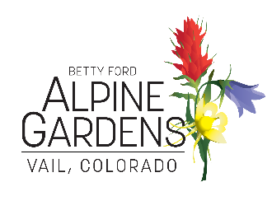

Betty Ford Alpine Gardens Facts
Established in 1986 as a 501c3 independent non-profit organization.
Named for Betty Ford in 1988 as a recognition of her many services to the Vail Community and the proximity of the Gardens in Ford Park.
Now known as Betty Ford Alpine Gardens
What: We are a Botanical Garden with stunning displays of plants, from traditional perennial borders to native rock gardens and pollinator gardens. 5 acres of land, 4 acres cultivated and 1 acre of riparian woodland adjacent to Gore Creek. Plants are labeled and documented. Visit time from 30minutes to 1 hour. Add additional time to visit gift shop and Visitor Center exhibit in season.
Visit: Gardens are free and open to the public from dawn to dusk year-round. Donations appreciated. Maintenance and upkeep fully dependent upon donations. Snowshoes required in the winter and available for rent at the Education Center.
Visitor Center/Education Center: Open throughout the year from 10am to 4pm. Off season closings on weekends, check website. Free but donations appreciated. Features permanent interpretive displays with seasonal exhibits and tabletop activities for children.
Additional amenities: Family activities, docent led tours, educational programs, scavenger hunts, workshops year-round. Check website for full calendar of events.
The Gardens has a commitment to Alpine Plant Conservation and has staff entirely devoted to this cause. Additional information is available in the Visitor Center and on the website about these efforts.
Parking in Ford Park just East of the Gardens or in the Vail Parking structure. Fees may apply. See website for details. ADA parking opposite Ford Amphitheater with placard visible.
Gift Shops: Village Gift Shop open daily year-round in Vail Village, on West Gore Creek Drive near The Golden Bear. Schoolhouse gift shop in the Gardens from Memorial Day to Labor Day (refreshments available here).
Contact Information: (970) 476-0103 x 2 reception desk www.bettyfordalpinegardens.org

